DevOps day-8
1.Create or reuse a GitHub repository containing a simple application or static HTML project.
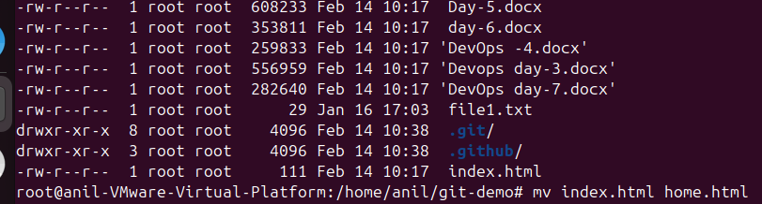

2.Navigate to the .github/workflows directory and create a YAML workflow file defining the CI pipeline.
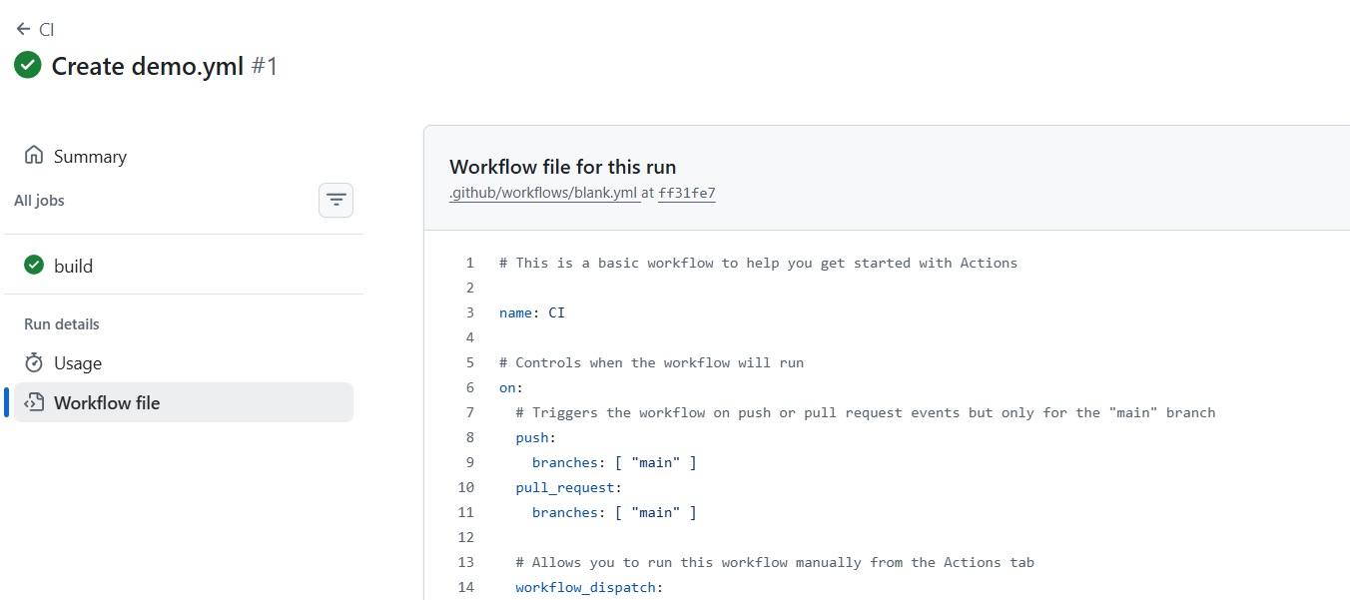

3.Configure the workflow to trigger automatically on every push or pull request event.
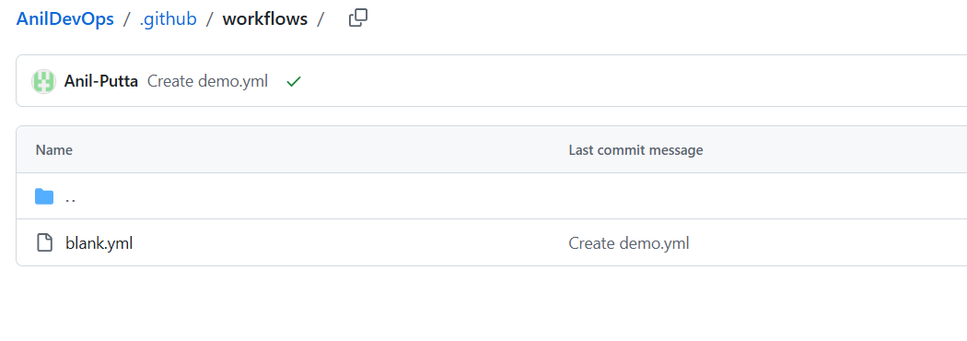
4.Add steps to checkout the code, install dependencies (if any), and run basic validation or test commands.


5.Include environment variables and understand how secrets are managed in GitHub Actions.
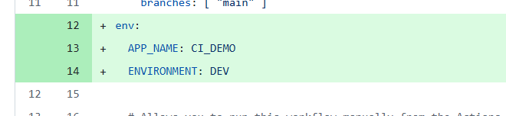

6.Run the workflow and observe execution logs for each step to understand pipeline stages.
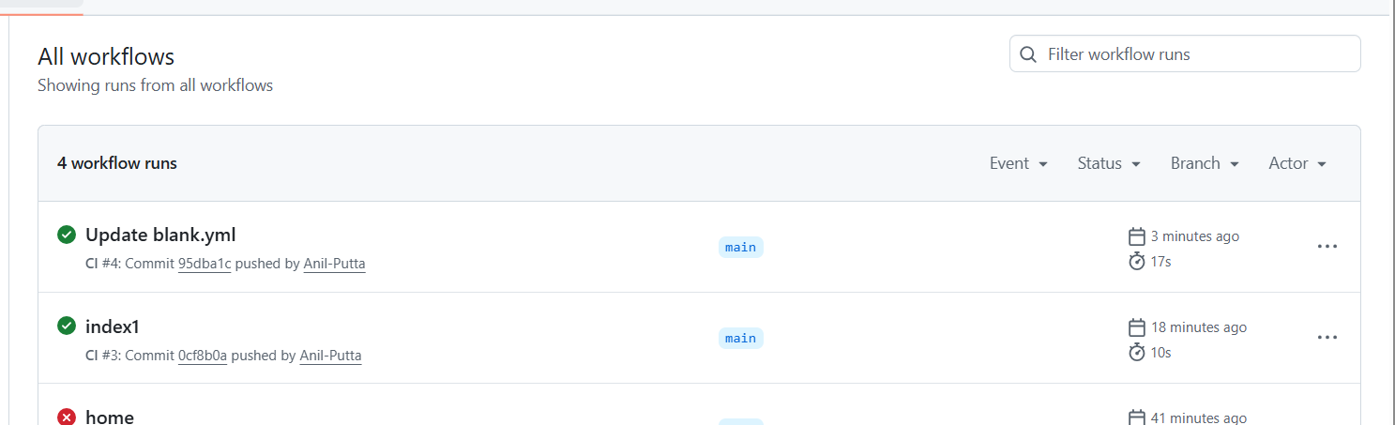
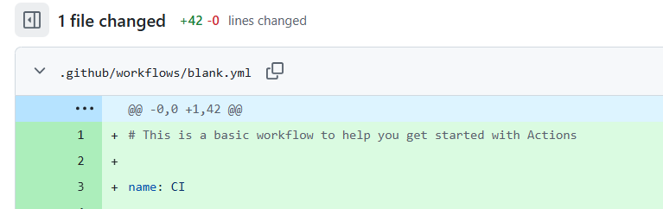
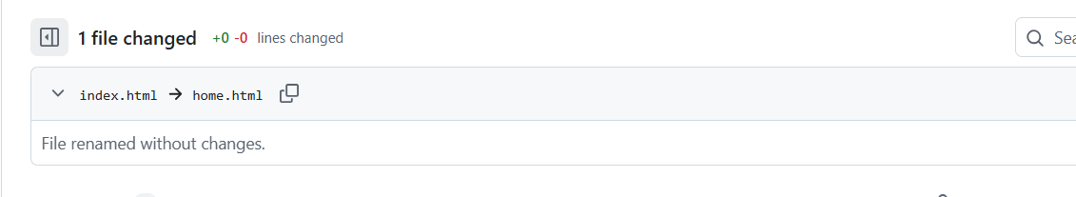
7.Modify the workflow intentionally to break and then fix it to understand failure handling.
